Assignment 6: Visual Analytics

group members: John, Liveris, Nikolaas, Jaysinh

Data:
We generate smaller data sets from the large data file in individual files for each location in the “world” in order to gain insight on which locations are the ones most affected or if there is any fixed pattern in certain locations at 15 minute time intervals. This approach allows us to single out possible locations that might have triggered the anomaly in the data geo graphically and also allows us to see whether the incursion or the anomaly is spread within and from that region and to what extent. Making use of the geo-coordinates and the provided region data, we can see a holistic view of the entire population of the bank.

For the first data handling step, we first aggregate the data on a large scale so as to show individual locations with their average number of connections, the average policy value over all the computers at that location and their location on the world map. This aggregation of the computers represents the situation at each location in terms of the change in their policy status over time and we allow the user to iterate through it.

The data table we generate is as follows:
Avg # of connections | Avg policy status | Avg activity flag | Longitude | Latitude
Table 1

The second layer of data representation consists of individual machine types and their respective connections at a given location as follows:
Machine function | Max policy status | Total # of connections | Longitude | Latitude
Table 2

Both table 1 and 2 are generated from an SQLite database of the large data set using python scripts. In order to make data loading and iteration faster, we only parse through the generated data sets in JavaScript when loading data into D3 in the form of CSV files exported from the database while leaving majority of the data mining tasks in python due to its effectiveness and versatility in handling strings and its powerful CSV and database handling modules.

Visualizations:
As of now, we have 2 primary visualizations that allow the user to have an effective overview of the overall data with the help of a time slider to iterate through the large collection of data. As an update to the earlier version of the visualization, we add a filter functionality to the visualization to allow the user control over the objects being visualized by breaking down the policy status (as color) and activity flag (as symbols) into 5 selections each and the user may check or uncheck the filter parameters as necessary. Another aspect of the visualization is that it has been tuned to represent locations with greater deviation in policy status and large number of connections more prominently as compared to the other cluster of locations in that region.

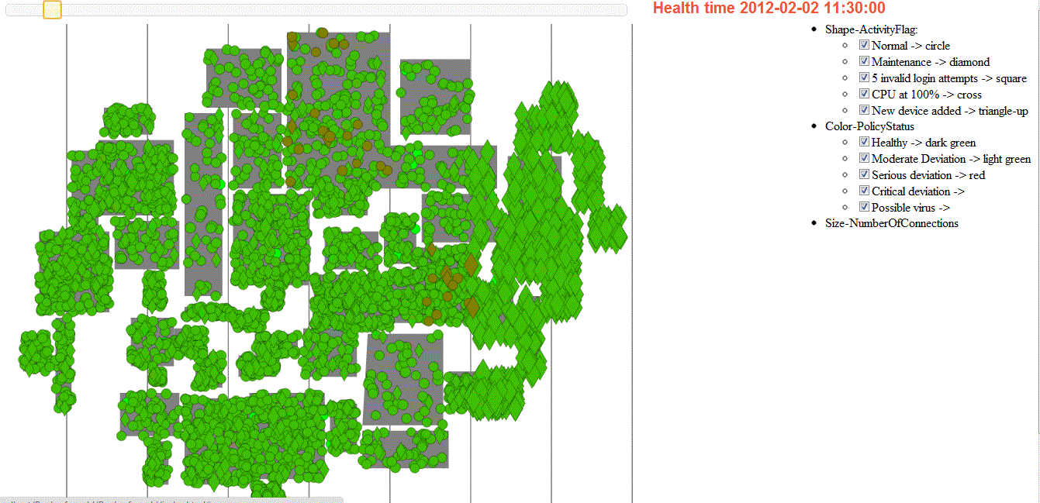

Another addition to the earlier visualization is the addition of an auxiliary scatter-plot that shows the machine type and the sum of the connections of each machine function represented explicitly on a bi-directional graph representing the number of connections for each machine type on the X axis, and the number of IP addresses represented on the Y axis upon selecting an object of interest in visualization 1. Each machine type is represented by symbols and the color of the symbols represent the max policy status of the total IP of all machine types at that location at that specific time step (15 minute interval).

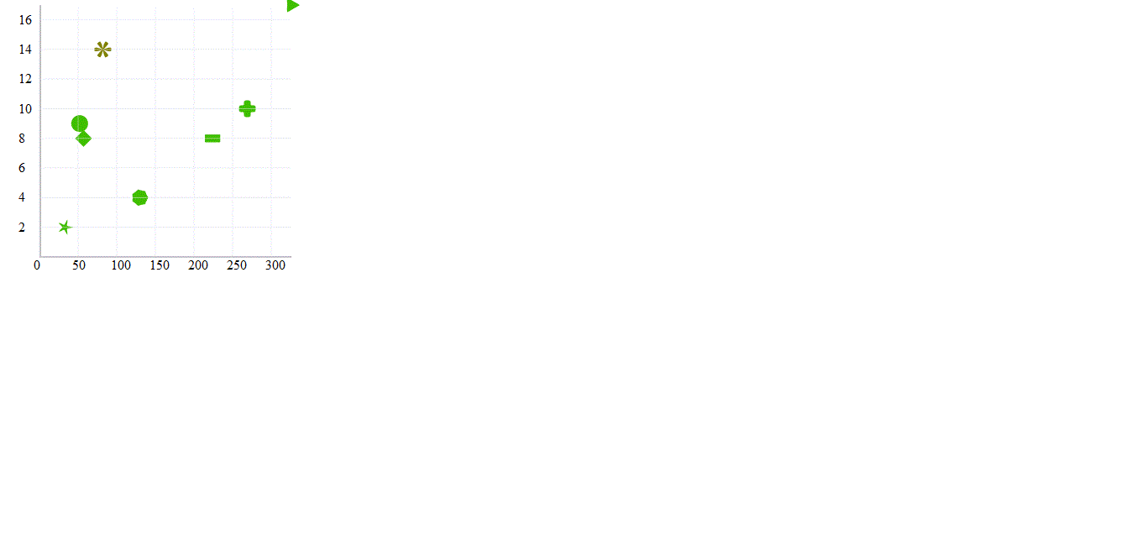

Observations:
On navigating through the visualizations, our team has based a hypothesis on the earliest emergence of erroneous activity starting at two prominent data centers in among the largest regions on the map. On deeper investigation though this aggregated samples of the data and its visual representation, we see some suspicious activity at these locations starting from 2nd February, 9:30am where the visualization 2 reveals this anomaly in machine functions of office computers, email servers, file servers and web servers. While focusing on these two locations throughout the time line of the data set, we see that the situation narrows down prominently to web and email servers over other systems.

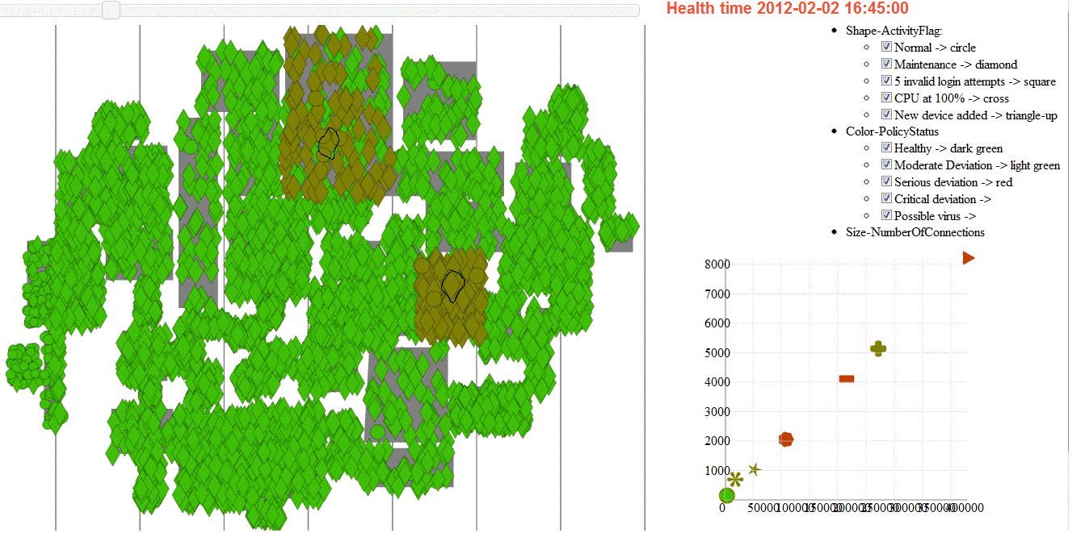
Over time, we see the policy status of these two machine types going from moderate deviation to critical deviation and the spread of this “virus” as we loosely term it, to other systems on the same location. After that we also observe spread of this “virus” predominantly to locations around that region but with slightly lower influence on their computers as compared to the two key data centers where the affliction worsens.

Areas that are far away from these two data centers show mild to no deviation in their policy status that may be assumed to be in regular bounds of operation.

Another point of interest in observing the change in policy statuses and number of connections, we see that during non-office hours, a lot of computers all over the map are still on when they are supposed to be turned off as the problem case states. However we are yet to develop a strong hypothesis on this matter. Possibly this question could be answered on further development of our visualization in the coming weeks.

It is understandable to assume that as data centers are key to data exchange and management in each region, it would not be uncommon for the spread to occur in nearby regions but what would be interesting to see is that the large data servers which may cater to wold wide data housing, the influence might trigger a chain reaction but this has yet to be concluded due to the high aggregation level of the data used for visualization.

One observation was that we didn't see a serious deviation in the average or the max number of connections established by the locations of interest which is contrary to what we believed to be the case where, if a computer is affected, it would either crash resulting in a major drop in the number of connections or it would shoot up the number of connections in such a way that it would be noticeable even on an aggregated level. Switching to a detailed level of data mining may reveal that there is indeed some connection of the number of connections with the policy status deviation.

Further development:
We discuss that both, visualizations 1 and 2 are key to generate strong insight and knowledge over our problem case with this data set, the abstraction level is still significantly high and we propose using some smarter and less human centered inference models generated by AI techniques we plan to implement in further development of the system. One such idea we discuss is to be able to pinpoint which specific computers are the root cause of the anomalies observed in our existing visualization and how the activity flag in each case plays a role in the deviation of its policy status.

A couple of cases we talked about was that; lets say:
- A USB stick was inserted into one of the computers when everything was functioning normally, and over time, the “virus” in the USB stick causes the situation in that computer to worsen affecting the policy status of that computer which might not be immediate but might be evident over a course of time.

- A “bugged” or “virus” laden email or web application might have cause the computer at a specific location to drastically affect its policy status over time and eventually spread to corresponding computers connected to this computer while establishing a connection. This also raises the probability that the root of the “virus” incursion might be in a data center that caters to a series of locations around. We hypothesize this due to the observation that majority of the computers affected in data centers belong to the machine class of web or email systems.

Keeping these questions in mind, we believe that it is crucial to delve deeper into the data from a macro to a micro perspective and tweak the system in a way that it is able to pinpoint the cause and the evolution of the anomaly based on an intelligent inference model that may be parameterized manually until the insight gained from the experience with the visualization is conclusive.

